Character with longest consecutive repetition

DESCRIPTION:
For a given string s find the character c (or C) with longest consecutive repetition and return:
(c, l)
where l (or L) is the length of the repetition. If there are two or more characters with the same l return the first in order of appearance.
For empty string return:
('', 0)

SOLUTION:
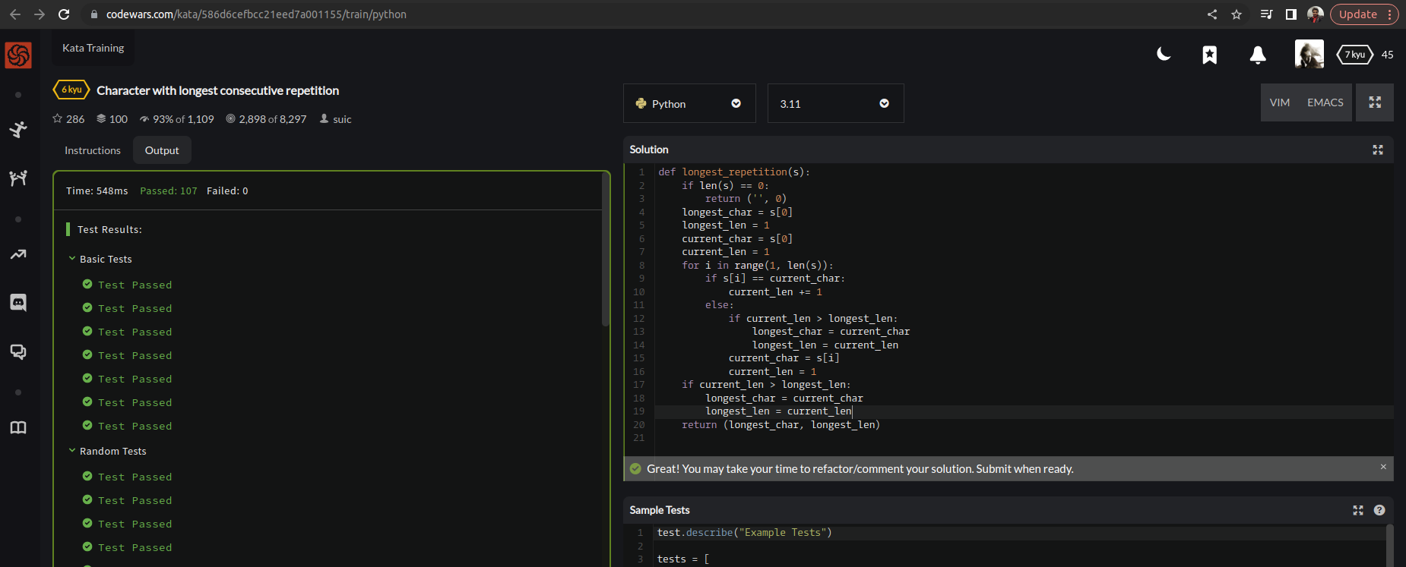

EXPLANATION:
This function takes a string s as input and returns a tuple containing the character with longest consecutive repetition and its length. If the string is empty, it returns ('', 0). We start by checking if the string is empty and returning the appropriate value. Otherwise, we initialize longest_char and longest_len to the first character in the string and its length, and current_char and current_len to the same values. We then iterate through the rest of the string, updating current_len when we encounter the same character as before and comparing it to longest_len when we encounter a new character. If current_len is greater than longest_len, we update longest_char and longest_len accordingly. Finally, we check if current_len is greater than longest_len one last time to handle the end of the string. We return the tuple (longest_char, longest_len) as the result.

